7.33: From Eq. (7.17), the force is
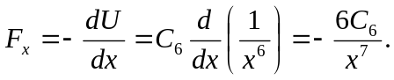
The minus sign means that the force is attractive.

